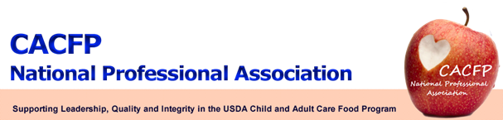

August 2012 Message of the Month



Voting for the new 2013 CACFP NPA board is now available. Please visit http://www.surveymonkey.com/s/CACFPNPA to cast your votes. All votes are completely confidential. The deadline to vote is September 7, 2012.

You can review each candidates profile by visiting the NPA website at www.cacfpnpa.org. On the right hand side of the home page, click on “view your candidate profiles here.”

All members are encouraged to vote for both the President-Elect and Treasurer positions. When voting for a Regional Representative, please vote only for one within your region. If there is only one candidate running in your region, you may still cast a vote for them to show your support. If you are unsure what region your state belongs in, it will be conveniently listed on the survey or you can go to the NPA website and click on “USDA Regional Offices.” Regions that do not have an opening for a Regional Representative will only be able to vote for the President-Elect and Treasurer positions.

To ensure integrity and fairness, a maximum of ten votes is allowed per state, so if you have more than ten (10) NPA members consisting of any combination of institutional and/or individual members, you will have to decide who will vote. We will take the first ten who vote from a state. (CACFP Bylaws April 2011, page 4)

Your vote counts, so please take the time to vote!

